**Appendix S1**

**Table S1.** Results of PERMANOVA and PERMDISP comparing the pairwise differences in isotopic niches of earthworm species at each study site

|  |  |  |  |
| --- | --- | --- | --- |
| Site | Species pair | PERMANOVA | PERMDISP |
| ABANDONED1 | *Allolobophora chlorotica-Aporrectodea caliginosa* | *F* = 2.86, *P* = 0.09 | *F* = 3.07, *P* = 0.09 |
|  | *Allolobophora chlorotica-Aporrectodea trapezoides* | *F* = 0.36, *P* = 0.58 | *F* = 2.22, *P* = 0.15 |
|  | *Allolobophora chlorotica-Lumbricus friendi* | *F* = 0.001, *P* = 0.97 | *F* = 2.96, *P* = 0.09 |
|  | *Allolobophora chlorotica-Lumbricus rubellus* | *F* = 1.25, *P* = 0.27 | *F* = 0.02, *P* = 0.88 |
|  | *Aporrectodea caliginosa-Aporrectodea trapezoides* | *F* = 2.24, *P* = 0.14 | *F* = 0.01, *P* = 0.91 |
|  | *Aporrectodea caliginosa-Lumbricus friendi* | *F* = 7.18, *P* = 0.01 | *F* = 0.07, *P* = 0.81 |
|  | *Aporrectodea caliginosa-Lumbricus rubellus* | *F* = 11.54, *P* = 0.002 | *F* = 2.21, *P* = 0.16 |
|  | *Aporrectodea trapezoides-Lumbricus friendi* | *F* = 0.88, *P* = 0.35 | *F* = 0.12, *P* = 0.74 |
|  | *Aporrectodea trapezoides-Lumbricus rubellus* | *F* = 4.71, *P* = 0.03 | *F* = 1.94, *P* = 0.17 |
|  | *Lumbricus friendi-Lumbricus rubellus* | *F* = 3.93, *P* = 0.06 | *F* = 2.53, *P* = 0.12 |
| ABANDONED2 | *Allolobophora chlorotica-Aporrectodea caliginosa* | *F* = 0.02, *P* = 0.90 | *F* = 0.01, *P* = 0.90 |
|  | *Allolobophora chlorotica-Aporrectodea trapezoides* | *F* = 0.25, *P* = 0.62 | *F* = 1.60, *P* = 0.23 |
|  | *Allolobophora chlorotica-Lumbricus friendi* | *F* = 0.45, *P* = 0.50 | *F* = 0.06, *P* = 0.78 |
|  | *Allolobophora chlorotica-Lumbricus rubellus* | *F* = 0.005, *P* = 0.94 | *F* = 0.06, *P* = 0.78 |
|  | *Aporrectodea caliginosa-Aporrectodea trapezoides* | *F* = 0.40, *P* = 0.56 | *F* = 3.34, *P* = 0.09 |
|  | *Aporrectodea caliginosa-Lumbricus friendi* | *F* = 0.50, *P* = 0.52 | *F* = 0.13, *P* = 0.72 |
|  | *Aporrectodea caliginosa-Lumbricus rubellus* | *F* = 0.004, *P* = 0.95 | *F* = 0.13, *P* = 0.71 |
|  | *Aporrectodea trapezoides-Lumbricus friendi* | *F* = 0.14, *P* = 0.71 | *F* = 0.88, *P* = 0.38 |
|  | *Aporrectodea trapezoides-Lumbricus rubellus* | *F* = 0.31, *P* = 0.59 | *F* = 0.83, *P* = 0.37 |
|  | *Lumbricus friendi-Lumbricus rubellus* | *F* = 0.50, *P* = 0.48 | *F* < 0.001, *P* = 1.00 |
| ARABLE1 | *Aporrectodea caliginosa-Aporrectodea trapezoides* | *F* = 12.41, *P* = 0.004 | *F* = 0.8, *P* = 0.38 |
| FOREST1 | *Aporrectodea caliginosa-Eisenoides lonnbergi* | *F* = 42.8, *P* = 0.001 | *F* = 1.21, *P* = 0.29 |
|  | *Aporrectodea caliginosa-Lumbricus rubellus* | *F* = 153.31, *P* = 0.001 | *F* = 1.60, *P* = 0.23 |
|  | *Aporrectodea caliginosa-Octolasion cyaneum* | *F* = 36.6, *P* = 0.001 | *F* = 0.88, *P* = 0.34 |
|  | *Eisenoides lonnbergi-Lumbricus rubellus* | *F* = 292.85, *P* = 0.001 | *F* = 4.96, *P* = 0.04 |
|  | *Eisenoides lonnbergi-Octolasion cyaneum* | *F* < 0.001, *P* = 0.99 | *F* < 0.001, *P* = 0.99 |
|  | *Lumbricus rubellus-Octolasion cyaneum* | *F* = 265.27, *P* = 0.001 | *F* = 3.81, *P* = 0.08 |
| FOREST2 | *Eisenoides lonnbergi-Lumbricus rubellus* | *F* = 113.83, *P* = 0.001 | *F* = 5.29, *P* = 0.04 |
|  | *Eisenoides lonnbergi-Metaphire hilgendorfi* | *F* = 36.23, *P* = 0.001 | *F* = 0.99, *P* = 0.36 |
|  | *Lumbricus rubellus-Metaphire hilgendorfi* | *F* = 6.93, *P* = 0.01 | *F* = 4.12, *P* = 0.04 |

**Table S2.** Bayesian standard ellipse area (SEAB, ‰2) estimates of earthworm species at each study site

|  |  |  |  |  |  |  |  |
| --- | --- | --- | --- | --- | --- | --- | --- |
| Site | Species | Mean | SD* | Mode | Lower 95% HDI* | Upper 95% HDI* | *n* |
| ABANDONED1 | *Allolobophora chlorotica* | 14.82 | 6.04 | 13.55 | 5.93 | 26.58 | 8 |
|  | *Aporrectodea caliginosa* | 5.29 | 1.42 | 5.06 | 2.85 | 8.08 | 16 |
|  | *Aporrectodea trapezoides* | 6.53 | 1.88 | 6.21 | 3.42 | 10.23 | 14 |
|  | *Lumbricus friendi* | 8.88 | 1.83 | 8.65 | 5.59 | 12.46 | 26 |
|  | *Lumbricus rubellus* | 10.91 | 2.47 | 10.58 | 6.67 | 15.76 | 21 |
| ABANDONED2 | *Allolobophora chlorotica* | 5.82 | 2.37 | 5.34 | 2.29 | 10.37 | 8 |
|  | *Aporrectodea caliginosa* | 11.10 | 6.35 | 9.49 | 3.47 | 22.85 | 5 |
|  | *Aporrectodea trapezoides* | 3.25 | 1.15 | 3.03 | 1.48 | 5.56 | 10 |
|  | *Lumbricus friendi* | 7.35 | 2.98 | 6.76 | 2.99 | 13.12 | 8 |
|  | *Lumbricus rubellus* | 7.26 | 2.95 | 6.69 | 2.87 | 12.93 | 8 |
| ARABLE1 | *Aporrectodea caliginosa* | 3.04 | 1.15 | 2.82 | 1.31 | 5.23 | 9 |
|  | *Aporrectodea trapezoides* | 4.18 | 1.31 | 3.93 | 2.08 | 6.80 | 12 |
| FOREST1 | *Aporrectodea caliginosa* | 0.42 | 0.14 | 0.40 | 0.21 | 0.69 | 12 |
|  | *Eisenoides lonnbergi* | 1.30 | 0.36 | 1.25 | 0.67 | 1.98 | 15 |
|  | *Lumbricus rubellus* | 0.27 | 0.08 | 0.26 | 0.14 | 0.42 | 14 |
|  | *Octolasion cyaneum* | 0.64 | 0.23 | 0.59 | 0.29 | 1.08 | 10 |
| FOREST2 | *Eisenoides lonnbergi* | 2.21 | 0.58 | 2.12 | 1.23 | 3.35 | 16 |
|  | *Lumbricus rubellus* | 0.99 | 0.33 | 0.93 | 0.47 | 1.63 | 11 |
|  | *Metaphire hilgendorfi* | 4.26 | 1.04 | 4.12 | 2.47 | 6.29 | 19 |

* SD: standard deviation; HDI: high density interval

**Table S3.** The percentage of the SEAB of species A that overlaps with the SEAB of species B at the study sites ABANDONED1, ABANDONED 2, and ARABLE1

ABANDONED1

|  |  |  |  |  |  |  |
| --- | --- | --- | --- | --- | --- | --- |
|  |  | Species B | | | | |
|  |  | *Allolobophora chlorotica* | *Aporrectodea caliginosa* | *Aporrectodea trapezoides* | *Lumbricus friendi* | *Lumbricus rubellus* |
| Species A | *Allolobophora chlorotica* | - | 13.5 | 35.1 | 41.9 | 20.9 |
| *Aporrectodea caliginosa* | 38.1 | - | 28.9 | 12.9 | 0.7 |
| *Aporrectodea trapezoides* | 79.1 | 23 | - | 59.7 | 16.6 |
| *Lumbricus*  *friendi* | 71.4 | 7.8 | 45.2 | - | 49.2 |
| *Lumbricus rubellus* | 27.7 | 0.3 | 9.8 | 38.2 | - |

ABANDONED2

|  |  |  |  |  |  |  |
| --- | --- | --- | --- | --- | --- | --- |
|  |  | Species B | | | | |
|  |  | *Allolobophora chlorotica* | *Aporrectodea caliginosa* | *Aporrectodea trapezoides* | *Lumbricus friendi* | *Lumbricus rubellus* |
| Species A | *Allolobophora chlorotica* | - | 50.4 | 20.6 | 6.0 | 9.6 |
| *Aporrectodea caliginosa* | 28.6 | - | 21.2 | 15.2 | 14.6 |
| *Aporrectodea trapezoides* | 37.2 | 67.5 | - | 32.4 | 36.2 |
| *Lumbricus*  *friendi* | 4.8 | 21.3 | 14.2 | - | 45.1 |
| *Lumbricus rubellus* | 8.5 | 22.8 | 17.7 | 50.3 | - |

ARABLE1

|  |  |  |  |
| --- | --- | --- | --- |
|  |  | Species B | |
|  |  | *Aporrectodea caliginosa* | *Aporrectodea trapezoides* |
| Species A | *Aporrectodea caliginosa* | - | 11.7 |
| *Aporrectodea trapezoides* | 8.8 | - |

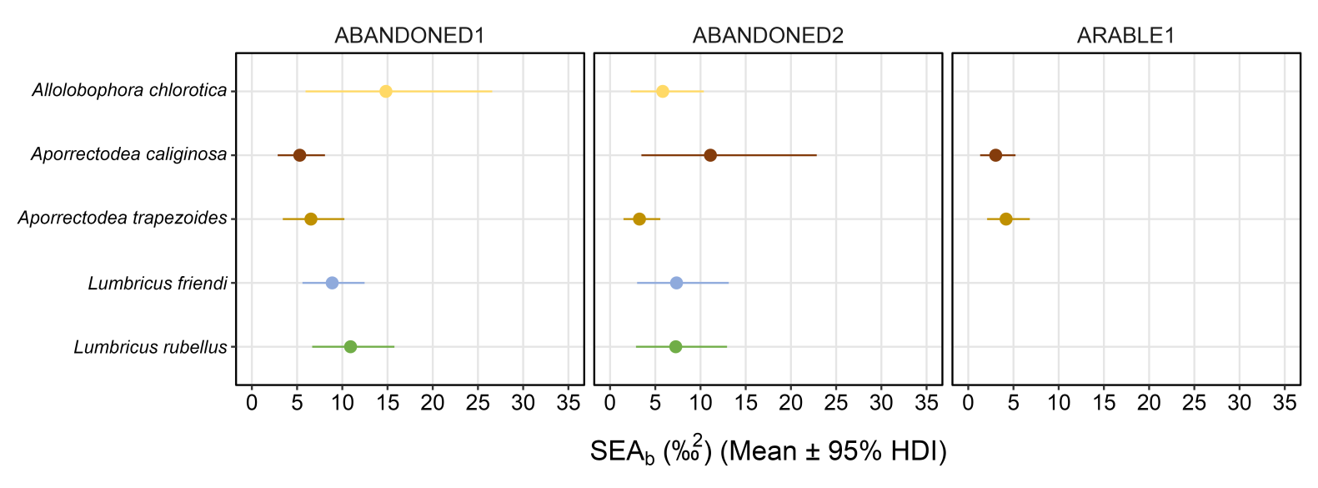

**Figure S1.** Bayesian standard ellipse area (SEAB) (mean ± 95% HDI) of the earthworm species at the study sites ABANDONED1, ABANDONED2, and ARABLE1. See Table S1 for detailed numerical results.

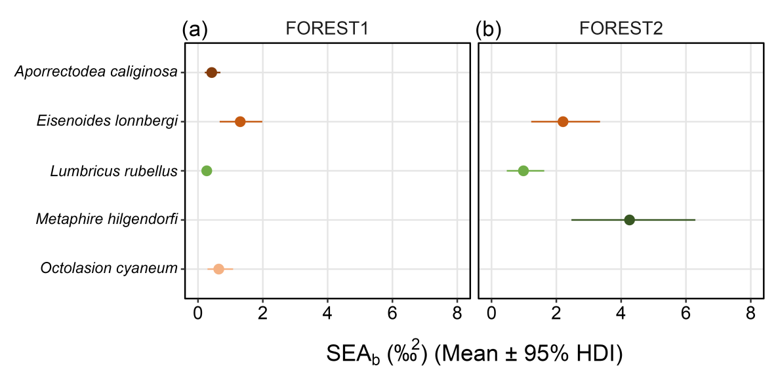

**Figure S2.** Bayesian standard ellipse area (SEAB) (mean ± 95% HDI) of the earthworm species at the study sites FOREST1 and FOREST2. See Table S1 for detailed numerical results.